

MEMORANDUM

TO: NYMEX ACCESS® Users
FROM: NYMEX ACCESS® Customer Service Center
RE: Login Instructions to the New Web-Based System
DATE: August 21, 2001

This document explains the method by which to login to the new NYMEX ACCESS® trading system. The system is being made available through August 31, 2001 in a Beta Test mode. You are strongly encouraged to login to this system to prepare for the production release of the web-based NYMEX ACCESS®. There are several one-time setup tasks that must be performed in order to successfully login to the system to ensure that you can trade when the cut-over occurs to the new system on Monday, September 3, 2001 for trade date September 4, 2001. Two of these important tasks that must be accomplished are:

- Download and install a Citrix client upon initial connection to the www.nymexaccess.com website.
- If your workstation is behind a firewall, Port 1494 must be opened for inbound and outbound traffic.

Please use the following instruction to login to the new NYMEX ACCESS® system operating in a Beta Test mode.

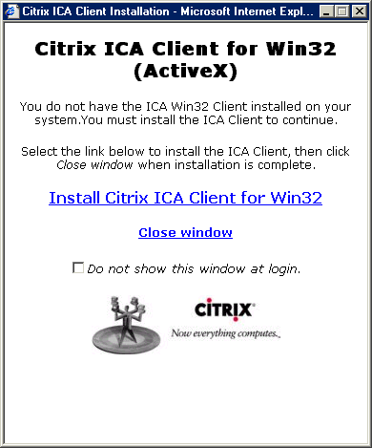
Point your browser to www.nymexaccess.com and you should receive the following login.

2. Single-click on the Install Citrix ICA Client for Win32 hyperlink

3. Select "run" or "open" the application. Do not save the application to disk.

4. If you get a message as follows, respond "yes."

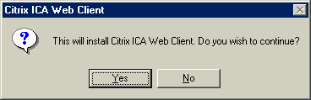
5. Read the Citrix agreement and respond "yes" if so desired.

6. You should receive a message indicating success as follows:

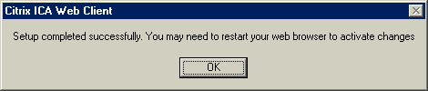
7. Select "OK"

8. Click on "Close Window"

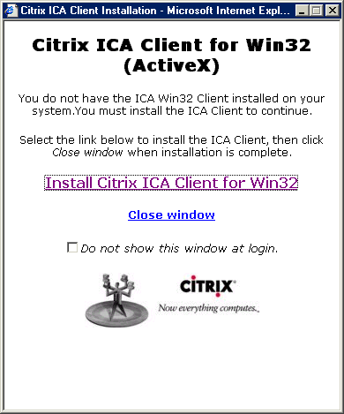

9. At the Login Citrix Nfuse window, type your normal NYMEX ACCESS® login ID in the username field. Select "Login".

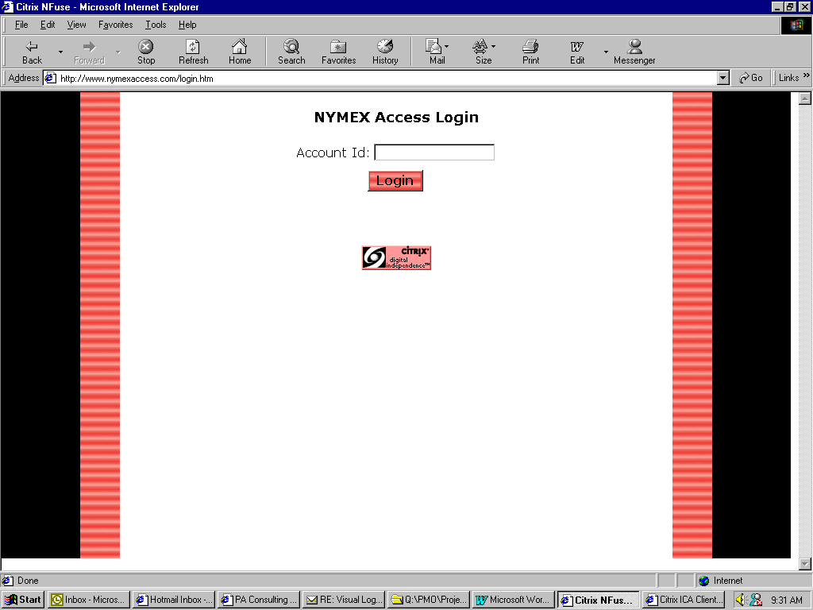

10. You should receive a window with the NYMEX logo on it as follows:

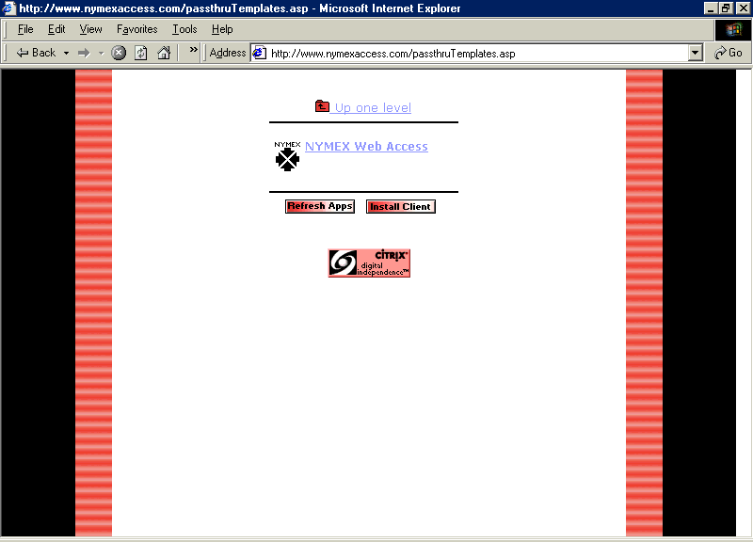
11. Single-click on the Nymex Web Access hyperlink

12. You should receive an Access Login window with your Login ID already input as follows:

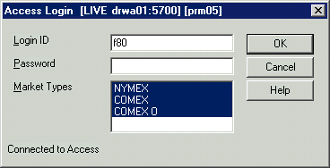
13. Type in the password "betatest" to access the NYMEX ACCESS® Betatesting System and select "OK."

14. The normal NYMEX ACCESS® Main Window should appear.

15. Set your preferences as you would desire them for trading and you’re ready to trade.
Some currently known problems to logging onto the system are listed below.
Please make sure you are doing the following:

- Click “Yes” on the Citrix Logon screen.
Use your mouse; do NOT hit Enter on your keyboard.
- Have your firewall Port 1494 Inbound and Outbound open.
- Click “Open” or “Open/Run from this file”.
Do NOT save to file.
- We are currently investigating the Credentials messages that reads:
“This operation requires user credentials to be specified,. The following session field was not set Nfuse-user.”

If there are further questions, you can call the Beta Test Control Center
212-299-2819 during the hours of 2:00 PM – 7:00 PM.

